

Mini Project Report - 01

Master of Computer Application – General
Semester – III

Sub: Web Technologies

Topic: LMS LOGIC PAGE
By
Name: ADITH PRAKASH
Reg no.: 2511022250062

Faculty Name: VEERA RAGHAV K

Faculty Signature: _______________

Department of Computer Application
Alliance University
Chandapura - Anekal Main Road, Anekal
Bengaluru - 562 106
August 2025
INDEX

FIG NO | NAME OF TABLE | PG NO
1 | INTRODUCTION | 2
2 | INPUT CODE | 3-5
3 | OUTPUT CODE | 6
4 | CONCLUSION | 7

INTRODUCTION

Login Page Project Description
This mini project is a responsive and user-friendly login page developed using HTML and CSS. The login page includes input fields for username and password, a login button, a forgot password link, and a sign-up option for new users. The main objective of this project is to demonstrate the use of HTML for creating the webpage structure and CSS for designing an attractive and responsive user interface. It helps learners understand the basics of web development, form design, styling techniques, and user-friendly webpage creation.

INPUT CODE
<html>
<head>
<title>Alliance University</title>
<style>
*{
color: white;
font-family: 'Segoe UI';
}

#i1,#i2{
margin-left: 20px;
border: none;
border-bottom: 2px solid white;
width: 250px;
background: transparent;
font: white;

}

#b1{
height: 40px;
width: 250px;
margin-left: 25px;
margin-bottom: 20px;
margin-top: 30px;
padding-top: 5px;
padding-bottom: 5px;
background-color: black;
border: 1px solid white;

}
#b1:hover{
background-color: white;
color: black;

}
form{
text-align: center;
<!-- border: 1px solid black; -->
margin-top: 20px;
}
img{
height: 200px;
width: 200px;
margin-top: 100px;
}
p{
margin-left: 150px;

}
select{
width: 250px;
margin-left: 20px;
padding-top: 4px;
padding-bottom: 4px;
background-color: grey;
}
#p1{
margin-top: -10px;
font-size: small;
color: white;
}
#p2,#p3,#p4{
margin-right: 110px;
font-size: 10px;
text-decoration: underline;
}

div{
margin-right: 110px;
font-size: 10px;
display: flex;
gap: -25px;
justify-content: center;
text-decoration: underline;
margin-top: -10px;
}
div,p{
color: gray;
font-size: 10px;
}

body{
background-color: black;
}

::placeholder{
color: white;
font-weight: bolder;
}

</style>
</head>
<body>

<form>
<!-- <h1>ALLIANCE UNIVERSITY</h1> -->
<img src="./Alliance_University_idFg0oxKYW_0.png"><br><br><br><br>

<!-- <label>Student reg no:</label> -->
<input id="i1" type="text" placeholder="Username"> <br><br><br>
<!-- <label">Student password:</label> -->
<input id="i2" type="password" placeholder="Password"> <br></br>
<button id="b1">Sign in</button>
<p id="p1">Forgot Password?</p>
<select>
<option id="b2">Sign in with third-party account</option>
<option>alliance Single sign on</option>
</select><br><br><br><br>
<p id="p2">View Course Catalog</p><br><br>
<p id="p2">© 1997-2026 Blackboard Inc. All Rights Reserved.</p>
<div>
<p>Help </p>
<p>Privacy and Terms of Use </p>
<p>Accessibility</p>
</div>

</form>

</body>
</html>

OUTPUT CODE

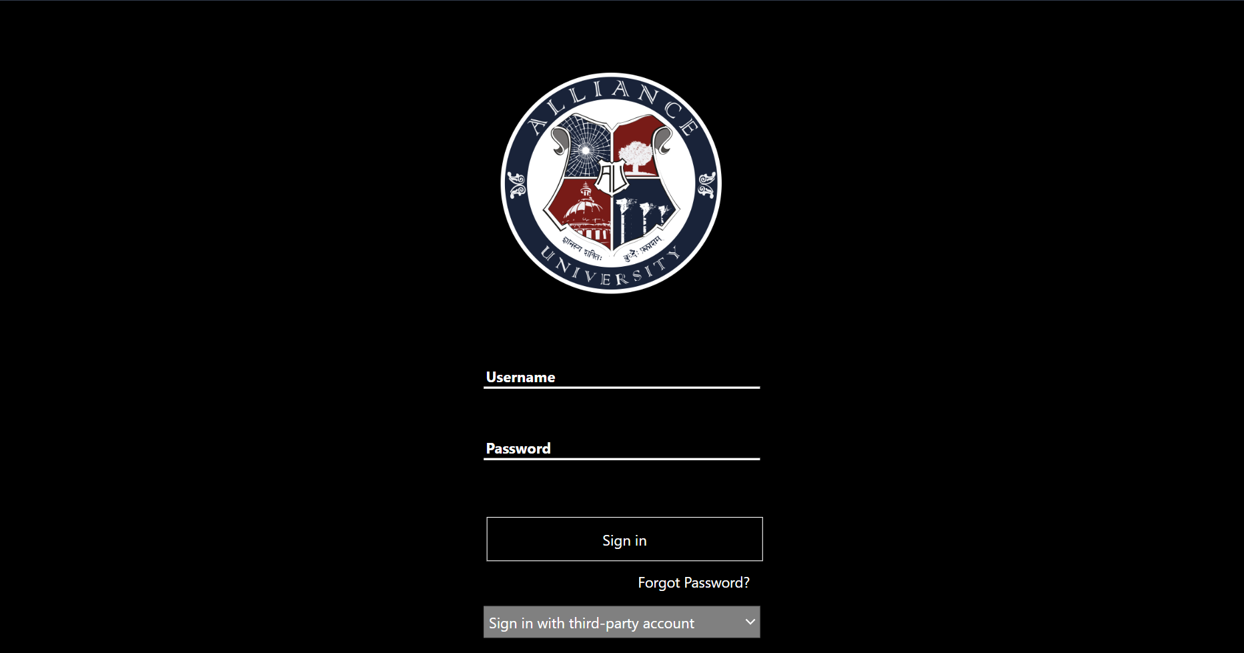



CONCLUSION

This mini project successfully demonstrates the creation of a simple and attractive Alliance University Login Page using HTML and CSS. Through this project, the concepts of webpage structure, styling, alignment, and responsive design were implemented effectively. It enhanced understanding of front-end web development and provided practical experience in designing a professional login interface. The project serves as a foundation for developing more advanced and interactive web applications in the future.

